

Cordys Build Framework Version 1.0

© 2003 Cordys R&D B.V. All rights reserved.
The information in this document is confidential and may be legally privileged and is protected by copyright law and international copyright treaty. The information contained in this document is subject to change without notice. Cordys R&D B.V. does not warrant that this document is error free. No part of this document may be reproduced, stored or transmitted in any form or by any means, electronic or mechanical, for any purpose, without the express written permission of Cordys R&D B.V. Cordys R&D B.V. assumes no liability for any damage incurred, directly or indirectly, from any errors, omissions, or discrepancies between the software and the information contained in this document.
Cordys BCP, Cordys WCP, Cordys CPC, Cordys CenterCourt, Cordys Integrator, Cordys Orchestrator, Cordys Portal, Cordys BAC, Cordys for BaanIV, ACR Cockpit, Sales Cockpit, Customer Cockpit and Cordys logo are trademarks of Cordys R&D B.V.
All other trademarks mentioned here are trademarks or registered trademarks of their respective owners and should be noted as such. Any unauthorized use may violate trademark laws and may be subject to damages and penalties.

Contents
Contents 3
1. About Build Framework 4
1.1 Mission 4
1.2 Intended Audience 4
1.3 Prerequisites 4
1.4 How this guide is organized 5
1.5 Documentation Conventions 6
1.6 Abbreviations 7
1.7 References 7
2. Overview 8
3. Installation of Eclipse 9
3.1 Features 9
3.2 Installation 9
4. IDE Integration & Plug-in 10
4.1 New Cordys Project Wizard 10
5. Project Structure 13
5.1 Project Hierarchy 13
5.2 Batch File 15
5.3 Build File 16
5.3.1 Build Specifications 16
5.3.2 Invoking the build file 21
5.3.3 Running the build 22
5.4 Properties File 23
5.4.1 Build Properties 23
5.4.2 User Properties 26
Appendix I - Build Framework Content Types 27
Appendix II - Content XML Formats 29

- About Build Framework

Mission

- An integrated and structured view of the project for the configuration engineer, build manager and the other team members.
- Standard platform and a development environment for the complete project for the entire team.
- Version control of the content types.
- An automated process to carry out builds (at scheduled times) together with basic verification tests done (unit tests) and notification of build status and changes in the build.
- Create a completely cooked distribution which can just be placed on a web site or a CD, so that testing can start right away.

Intended Audience
This document is intended for the configuration managers, development managers and builds engineers who are planning to integrate the working environment of their projects along with the build process so that it can run in an unattended mode. This document throws light on the continuous build loop process and explains in detail as to how one can build a great automated build management process.

Prerequisites
The software that is required on the developer machine are as follows:
- Cordys ECX 1.3 or higher
- Eclipse IDE 2.1.1 or higher (or any other IDE such as Visual Studio)

How this guide is organized
The Installation Guide is organized as follows:
Chapter 1, “About Build Framework”
Provides introductory information about the Cordys Build Framework.
Chapter 2, “Overview”
Provides an overview of the Cordys Build Framework.
Chapter 3, “Installation of Eclipse”
Provides a step-by-step explanation to install and configure Cordys Build Framework on the Developers Machine.
Chapter 4, “IDE Integration & Plug-in”
Describes the IDE Integration of Eclipse with the Cordys Build Framework.
Chapter 5, “Project Structure”
Describes the working of the Cordys Build framework and explains the developer about details of project structure, tools and ANT build.

Documentation Conventions
Style Name | Example | Used For
Navigation | Browse to user → system → system administrator | Listing down the navigation steps from a menu or context menu or any standard windows navigation functionality.
Path | The install directory is /cordys/wcp/xmlstore/  Or, Styles sheets are stored in the folder styles | This style is used for depicting a path, which may include the folders, files and computer names or any of them individually.
Button | Click ok to generate tables or cancel to exit.  Or, click new icon for a new document | A button or icon is represented in this style. This is always in small caps.
Key stroke | Press the return key | This is used for a key on the keyboard
Method | Select the method getemployeeid and click on add to add the Method Set. Remove the unnecessary method sets using the remove button. | A method name is always depicted with this style; the case should be followed as per the name of the method.
Parameter | Type server Name when asked for server name | The parameter style is used to highlight the name of the parameter for which a value has to be entered.
Value | Type <wcp_server_1> when asked for server name | The style value is used for a sample value or instructed value for computer names, etc. This should be replaced by the user’s value excluding the < and > at the input field in the software.
Code text | <code> this is a sample </code> | This style is used for code text.

Abbreviations
Abbreviation | Description
BCP | Business Collaboration Platform
WCP | Web Collaboration Platform
CARS | Cordys Administrative Repository Service
ECX | Enterprise Collaboration Exchange
GA | General Availability
ISV | Independent Software Vendor
SP | Service Pack
CVS | Concurrent Versioning System
VSS | Visual Source Safe
CC | CruiseControl
IDE | Integrated Development Environment

References
- Refer Cordys Integrator documentation for more details.
- Refer Cordys Build Framework Installation Guide for Eclipse installation.

- Overview

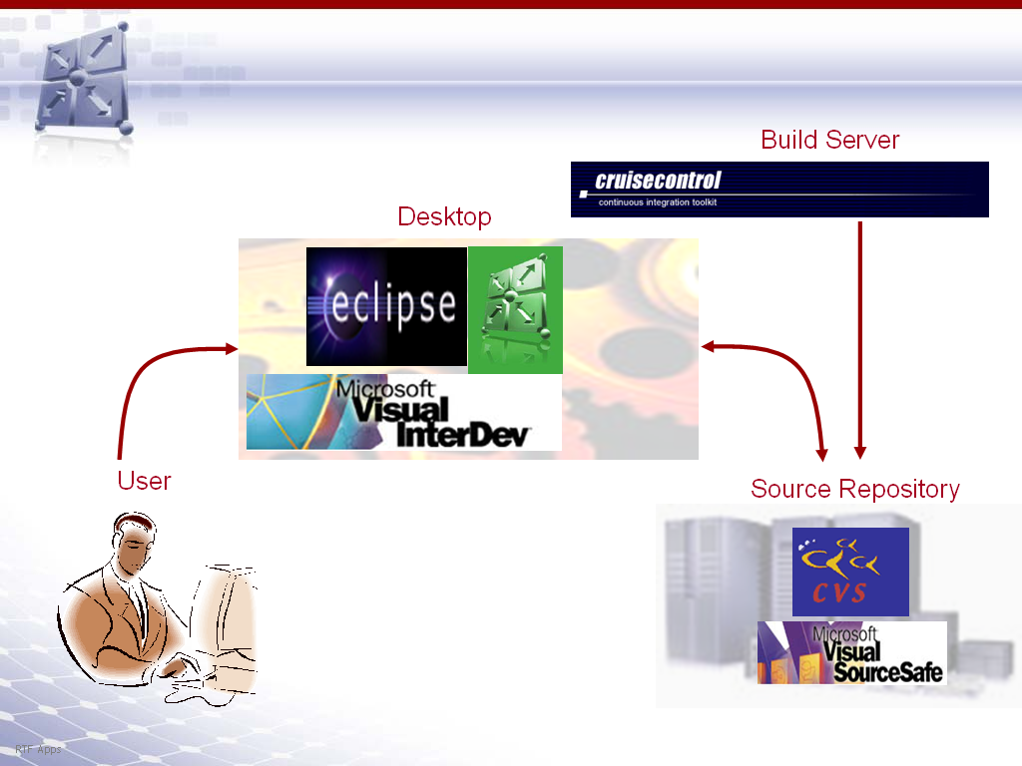

The above picture depicts the complete build framework environment where the user works on his/her desktop and uses his own ECX rather than a centralized ECX. The user updates his source files and contents on the Source Repository. The build server with the CruiseControl running monitors the Development server for modifications and the build happens automatically and is transparent to the user.
Build Framework Components
- Ant build structure & configuration
- IDE integration plug-in
- Build server configuration
The user has to install Eclipse. Then the user unzips the Eclipse plug-in jar and extracts the contents to a suitable folder.

- Installation of Eclipse

This chapter elaborates on the features of Eclipse, its installation and the third-party plug-ins to be configured as well as the setup of Eclipse as the IDE for project development

Features
Eclipse is an open and extensible IDE, which facilitates a seamless integration of plug-ins. It is designed to run on multiple operating systems while providing robust integration with each underlying OS.
Some of the salient features of Eclipse are:
- Support for GUI, as well as non-GUI application development
- Extensible. Can implement new functionality via plug-ins
- No licensing charges.
- In-built support for CVS, VSS, Apache Ant, JUnit
- Many different perspectives of the same object provided, viz., Resource perspective, java perspective, Debug perspective.
- Multiple views which provide information of the object is available, viz., Resource Navigator, Outline, Properties, Tasks, Bookmarks.
- Java features
  - Java files get auto compiled as soon as they are saved
  - Easy debugging. Corrective actions are suggested by the tool itself in many places.
  - Auto generation of ‘get’ and ‘set’ methods for class variables provided.

3.2 Installation
- Download Eclipse.
- Extract the ZIP File with folders to any folder on the system, henceforth referred to as INSTALL_DIR
note

install_dir should not have any spaces.

- Run the application "eclipse.exe" in the extracted files to start the editor.
- If VSS is used as the repository, the Eclipse plug-in for VSS is to be downloaded and extracted to INSTALL_DIR/plug-ins.

- IDE Integration & Plug-in

New Cordys Project Wizard
The Cordys Eclipse Plug-in enables the integration of the build structure and the ant tasks for content management with the Eclipse IDE. It is distributed as a ZIP file. To install the plug-in, just extract the contents to the Eclipse Installation Directory.
Typically the New Project Creation Wizard in Eclipse enables you to specify a project name and workspace location. If it is a Java Project, we also get a Java Capability Configuration Page, where the source and destination folders as well as the required libraries can be specified.
The Cordys Eclipse Plug-in is invoked from the "New Project" Menu:
File->New->Project->Java->Cordys Project
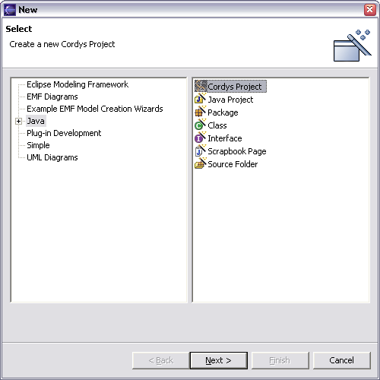

Select "Cordys Project" and click "Next". You will get a screen that will enable you to specify a name for the new Project and also specify a location for its workspace. The default location is:
<ECLIPSE_HOME>\workspace\<PROJECT_NAME>

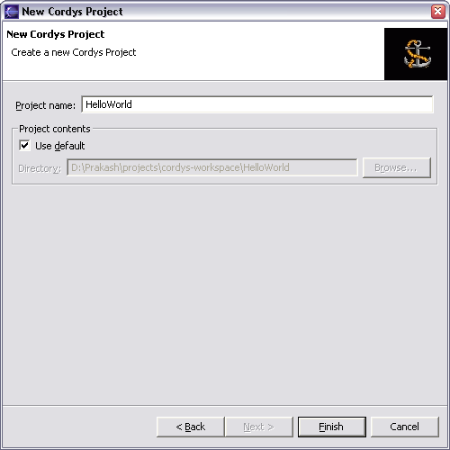

Now click Finish. The Plug-in will perform the following tasks:
- Create the build structure
- Create the files required for the Project-.classpath, .project and .cvsignore
- Create the files required for the build process-build.xml, build.bat and build.properties
- Insert the required libraries into the 'lib' and 'sdk' folders
- Setup the Cordys Ant Builder for the Projects

- Project Structure

This chapter elaborates on the project hierarchy adopted for development, build and distribution alike.

Project Hierarchy
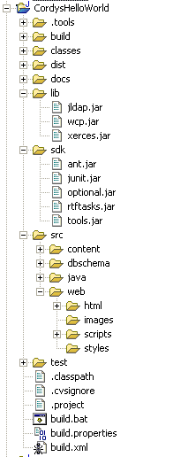

The direct folders under each project are
- src: This folder holds all the source codes.
  - java - Backend specific code
  - web – User interface related content as .htm, .js , .css files
  - dbschema - DB specific files as install.sql, uninstall.sql for the DB and create table scripts are here.
  - Content – This folder is the most important folder of the build framework. The content types of each user are backed up and stored as .xml files, facilitating versioning and management. There exists an xml file for each content type in Coryds (organizational and isv) as Menus.xml, Roles.xml, Methodsets.xml, FilSystem.xml, Prompts.xml.
- test: This holds the unit test programs.
- sdk: The jar files needed as the standard for any project such as ant.jar, junit.jar exist here. The ant.jar here is extended from the standard apache ant jar file and the customized tasks have been added as taskdefs. The jar rtftasks.jar uses the custom tasks in ant.jar and holds all the class files for the export, import and isv creation operations.

Advanced

Custom tasks in rtftasks.jar
isv (pluggable content types)
exportcontent (utility task)
importcontent (utility task)
deletecontent (utility task)

- lib : This holds the jar files specific to this project as Cordys jars – wcp.jar, jldap.jar
- docs: This folder will store the documents prepared.
- classes: This folder is Eclipse specific, where the class files are directed on compilation and after each default project build.
- build: This is a temporary folder created for backing up the intermediate files created during the build loop.
- dist: The deliverables from the build of this project as a jar or an isv along with the documentation are directed here.
- .tools: This contains Cordys ant builder tool. This is an External Builder which when invoked sets the appropriate classpath and runs the build file, which will create the ISV.
In addition to these folders, each project has the following files
- build.xml
- build.bat (command line invocation possible)
- build.properties (can be overridden)
- user.properties (specifying the user preferences for the build as ECX, organization, skip javadocs generation)
- .classpath (needed only for Eclipse integration )
- .project (needed only for Eclipse integration)

Batch File
Build.bat sets the classpath for ant, with the jars existing in the sdk folder of this project.

@echo off

=====================================================================
REM RTF Build script
REM =====================================================================
REM Launches ant with the proper build file and proper classpath
REM Pass specific targets as arguments to this build file if needed
REM =====================================================================

setlocal
if not defined JAVA_HOME goto :NoJavaFound
if not defined CORDYS_HOME goto :NoCordysFound

set PATH=%CORDYS_HOME%\WCP\bin
set CLASSPATH=

set ANT_CP=%CD%\sdk\ant.jar
set ANT_CP=%ANT_CP%;%CD%\sdk\optional.jar
set ANT_CP=%ANT_CP%;%CD%\sdk\junit.jar
set ANT_CP=%ANT_CP%;%CD%\sdk\tools.jar
set ANT_CP=%ANT_CP%;%CD%\sdk\rtftasks.jar
set ANT_CP=%ANT_CP%;%CD%\sdk\optional.jar
set ANT_CP=%ANT_CP%;%CD%\lib\jldap.jar
set ANT_CP=%ANT_CP%;%CD%\lib\wcp.jar
set ANT_CP=%ANT_CP%;%CD%\lib\xerces.jar

%JAVA_HOME%\bin\java.exe -cp %ANT_CP% org.apache.tools.ant.Main %*
goto :end

:NoJavaFound
echo JAVA_HOME environment variable is not set. Set it pointing to the Java installation root directory.
goto :end

:NoCordysFound
echo CORDYS_HOME environment variable is not set. Set it pointing to the Cordys installation root directory.
goto :end

:end
endlocal

Build File

Build Specifications
This ant build file has the following main targets:

cleanall Cleans all output directories including build and dist
compile Compiles Java source files
in the folder $src and copies to $build.classes
dbschema Copies database scripts to the build folder
deletecontent Deletes the roles, method sets and menus
deploy-web Copies web resources to the Cordys web folder
dist Creates a distribution of the project after running tests.
exportcontent Exports the ldap roles, method sets and menus
importcontent Imports the roles, method sets and menus
isv Creates an ISV package
jar Compiles Java sources and creates a JAR file
test Runs the unit tests
web Copies web resources to the build folder
javadocs Generates javadoc for the source files

<project default="dist" basedir=".">
<!-- Generic project build file -->

<property environment="env" />
<property file="user.properties" />
<property file="build.properties" />

<!--Classpath used for compiling sources -->
<path id="classpath">
<fileset dir="${lib.dir}">
<include name="**/*.jar"/>
</fileset>
</path>

<!--Pattern set which matches all Non CVS folders -->
<patternset id="all.non.cvs.files">
<include name="**/*"/>
<exclude name="**/CVS"/>
</patternset>

<!--Target for cleaning temporary distribution folders -->
<target name="cleandist">
<delete dir="${dist.dir}"/>
</target>

<!--Target for cleaning temporary build folders -->
<target name="cleanbuild">
<delete dir="${build.dir}" />
</target>

<!--Target for cleaning all temporary distribution and build folders -->
<target name="cleanall"
description="Cleans all output directories including build and dist"
depends="cleanbuild,cleandist"
/>

<!--Target for making folders for the build and distribution-->
<target name="init" depends="cleanbuild">
<mkdir dir="${build.dir}" />
<mkdir dir="${build.classes}" />
<mkdir dir="${build.jar}" />
<mkdir dir="${build.dbschema}" />
<mkdir dir="${build.web}" />
<mkdir dir="${build.test}" />
<mkdir dir="${dist.dir}" />
</target>

<!--Target for compiling java source files -->
<target name="compile"
description="Compiles Java source files"
depends="init">
<javac srcdir="${src.java}"
destdir="${build.classes}"
debug="${debug}"
deprecation="${deprecation}"
optimize="${optimize}">
<include name="**/*.java"/>
<classpath refid="classpath"/>
</javac>
</target>

<!--Target for making jar file of project in build folder-->
<target name="jar"
description="Compiles Java sources and creates a JAR file"
depends="compile">
<tstamp>
<format property="now"
pattern="dd MMM yyyy hh:mm aa" />
</tstamp>
<jar jarfile="${build.jar}/${project.jar.name}.jar"
basedir="${build.classes}">
<manifest>
<attribute name="Created-By" value="${isv.owner}"/>
<attribute name="Java Version" value="${java.runtime.version} ${java.specification.vendor}"/>
<attribute name="Project Version" value="${project.name}-${project.version}"/>
<attribute name="Created-On" value="${now}"/>
</manifest>
</jar>
</target>

<!--Target for copying web resources to build folder -->
<target name="web"
description="Copies web resources to the build folder"
depends="init">
<copy todir="${build.web}">
<fileset dir="${src.web}">
<patternset refid="all.non.cvs.files" />
</fileset>
</copy>
</target>

<!--Target for copying database scripts to build folder -->
<target name="dbschema"
description="Copies database scripts to the build folder"
depends="init">
<copy todir="${build.dbschema}">
<fileset dir="${src.dbschema}">
<patternset refid="all.non.cvs.files" />
</fileset>
</copy>
</target>

<!--Target for creating API documentation and
copying documentation resources to build folder -->
<target name="docs" depends="init" unless="skip.docs">
<mkdir dir="${build.docs}" />
<copy todir="${build.docs}">
<fileset dir="${docs.dir}">
<patternset refid="all.non.cvs.files"></patternset>
</fileset>
</copy>
</target>

<target name="javadocs" depends="init" unless="skip.javadocs">
<mkdir dir="${build.apidocs}" />
<javadoc
packagenames="${javadoc.packagename}.*"
sourcepath="${src.java}"
destdir="${build.apidocs}"
author="${javadoc.author}"
version="${javadoc.version}"
use="${javadoc.use}"
private="${javadoc.private}"
windowtitle="${javadoc.windowtitle}"
doctitle="${javadoc.doctitle}">
<classpath refid="classpath" />
</javadoc>
</target>

<!--Target for creating ISV package -->
<target name="isv"
description="Creates an ISV package"
depends="web,dbschema"
unless="skip.isv">
<isv
organization="${isv.org}"
owner="${isv.owner}"
productname="${isv.productname}"
version="${isv.version}"
type="standard"
name="${isv.name}"
filename="${isv.filename}"
destdir="${dist.setup}"
userdn="${isv.userdn}">
<organizationalroles contentfile="${src.content}/Roles.xml"/>
<menus contentfile="${src.content}/Menus.xml"/>
<methodsets contentfile="${src.content}/Methodsets.xml"/>
<filesystem>
<file srcdir="${build.jar}" destdir="/${project.name}" ecxdir="cordys_install_dir" />
<file srcdir="${build.docs}" destdir="/${project.name}/docs" ecxdir="cordys_install_dir" />
<file srcdir="${build.web}" destdir="/web/${project.web.name}" ecxdir="cordys_install_dir" />
<file srcdir="${build.dbschema}" destdir="/${project.name}/dbscripts" ecxdir="cordys_install_dir" />
</filesystem>
</isv>
</target>

<!--Target for copying resources from build to distribution -->
<target name="copy-dist" depends="copy-docs,copy-javadocs,copy-jar">
</target>

<target name="copy-docs" unless="skip.docs">
<copy todir="${dist.docs}">
<fileset dir="${build.docs}">
<include name="**/*" />
</fileset>
</copy>
</target>

<target name="copy-javadocs" unless="skip.javadocs">
<copy todir="${dist.apidocs}">
<fileset dir="${build.apidocs}">
<include name="**/*" />
</fileset>
</copy>
</target>

<target name="copy-jar" if="skip.isv">
<copy todir="${dist.setup}">
<fileset dir="${build.jar}">
<include name="**/*.jar" />
</fileset>
</copy>
</target>

<!--Target for compiling java unit test sources to build folder -->
<target name="compile-test" depends="init,compile" unless="skip.test">
<javac srcdir="${test.java}"
destdir="${build.test}"
debug="${debug}"
deprecation="${deprecation}"
optimize="${optimize}">
<include name="**/*.java"/>
<classpath>
<pathelement path="${build.classes}" />
<path refid="classpath" />
</classpath>
</javac>
</target>

<!--Target for running tests -->
<target name="test" depends="init,compile-test" description="Runs the unit tests"
unless="skip.test">
<junit printsummary="no" haltonfailure="yes">
<classpath>
<pathelement path="${build.classes}" />
<pathelement path="${build.test}" />
<path refid="classpath" />
</classpath>
<formatter type="plain" usefile="false" />
<batchtest>
<fileset dir="${test.java}">
<include name="**/*Test.java"/>
</fileset>
</batchtest>
</junit>
</target>

<!--Target for making distribution of the project -->
<target name="dist"
description="Creates a distribution of the project after running tests."
depends="cleandist,test,jar,docs,javadocs,isv,copy-dist">
</target>

<!--Target for exporting content like roles, methodsets or menus
from ISV package or organization -->
<target name="exportcontent"
description="Exports the ldap roles,method sets and menus">
<contentexport
content="${isv.content}"
dn="${isv.org}"
userdn="${isv.userdn}"
destdir="${src.content}"
/>
</target>

<!--Target for deleting content like roles, methodsets or menus
in the organization mentioned -->
<target name="deletecontent"
description="Deletes the roles,method sets and menus">
<contentdelete
content="${isv.content}"
organization="${isv.org}"
userdn="${isv.userdn}"
/>
</target>

<!--Target for importing content like roles, methodsets or menus
to the specified organization -->
<target name="importcontent"
description="Imports the roles,method sets and menus">
<contentimport
content="${isv.content}"
organization="${isv.org}"
srcdir="${src.content}"
userdn="${isv.userdn}"
/>
</target>

<!--Target for deploying web resources to the Cordys web folder-->
<target name="deploy-web"
description="Copies web resources to the Cordys web folder">
<copy todir="${env.CORDYS_HOME}/web/${project.name}">
<fileset dir="${src.web}">
<patternset refid="all.non.cvs.files" />
</fileset>
</copy>
</target>

</project>

Invoking the build file

Command Line Invocation
Every project root in the build framework has a BAT File 'build.bat'.
This BAT File basically sets the classpath for ANT and calls ANT build file i.e. 'build.xml' in the same directory.

If the project 'TestProjectBuild' where checked out to the folder D:\TestProjectBuild, then the developer can change the path to the directory in the command prompt and use build as command to invoke the build file.

D:\>cd D:\TestProjectBuild
D:\TestProjectBuild >build

For setting the classpath, the BAT file uses the project's libraries from 'lib' folder.

Eclipse Invocation
On building the project as Project->Build Project, by default the modified java files are compiled. Here, the Cordys ANT Builder tool is launched and the build batch file of this project is run, which sets the requisite classpath for ant, overriding the system classpath and invokes build.xml of this project.

From Build Server:

The batch for the project is run which invokes the build.xml via delegating build file which is specific to each project.

Running the build
The build can also be run specifying a single target.
<!-- To perform a single target -->
build exportcontents
build importcontents
build deletecontents

Properties File

Build Properties
Build file refers to the default.properties file for settings.
Through the build.properties, the user can specify the organization name (through which he can extract the contents), the user-dn (used to authenticate the user), the content type (roles, methodsets, menus, xmlstore), other ISV details, like the ISV name, version, productname. The build.properties also allows the user to set the product javadoc properties and the details about the build structure.
The properties are listed in the table below:

Attributes | Default Value (Can be edited) | Remarks
project.name |  | The project name and the version will be combined to form the jar file name
project.version
project.web.name
project.jar.name
src.dir | ./src | The place where the source files are located. The java related files, web related files, database schemas file and the content files are placed under source folder.
src.java | ${src.dir}/java
src.web | ${src.dir}/web
src.dbschema | ${src.dir}/dbschema
src.content | ${src.dir}/content
test.dir | ./test | The place where the unit test related files are stored
test.java | ${test.dir}/java | The place where the unit test related files are stored
docs.dir | ./docs | The location where the project related docs are stored.
lib.dir | ./lib | The location where the library dependencies are stored.
build.dir | ./build | The location for storing the intermediate directories during the build process.
build.classes | ${build.dir}/classes
build.jar | ${build.dir}/jar
build.web | ${build.dir}/web
build.test | ${build.dir}/test
build.docs | ${build.dir}/docs
build.apidocs | ${build.dir}/apidocs
build.dbschema | ${build.dir}/dbschema
dist.dir | ./dist | The location where the distributable shall be stored
dist.apidocs | ${dist.docs}/api | The location where the distributable shall be stored
dist.setup | ${dist.dir}/setup | The location where the distributable shall be stored
dist.docs | ${dist.dir}/docs | The location where the distributable shall be stored
debug | on | Compiler options
optimize | on | Compiler options
deprecation | off | Compiler options
javadoc.packagename | com.cordys.rtf | Javadoc options
javadoc.author | true | Javadoc options
javadoc.private | true | Javadoc options
javadoc.use | true | Javadoc options
javadoc.version | true | Javadoc options
javadoc.windowtitle | ${project.name} API | Javadoc options
javadoc.doctitle | ${project.name}${project.version} | Javadoc options
isv.owner | Cordys | ISV package properties.
isv.productname | ${project.name} | ISV package properties.
isv.version | ${project.version} | ISV package properties.
isv.name | ${isv.owner}${isv.productname} ${isv.version} | ISV package properties.
isv.filename | ${project.name}-${project.version} | ISV package properties.
isv.content | roles, menus, methodsets, xmlstore | ISV package properties.
isv.org |  | ISV package properties.
isv.userdn | =${env.USERNAME},cn=organizational users,${isv.org} | ISV package properties.

User Properties
The parameters set in this file can be overridden by reassigning them to our in another file ‘user.properties’. Eg. The machine password, destination directory on the client side is set in the user.properties file. The user can also decide to run the build file skipping certain activities as generating javadocs, creating isv by defining properties skip.javadocs, skip.isv in the user properties file. The user.properties is used to connect to remote machines. It is a client side specific file, (which is not checked into the CVS/VSS).

Appendix I - Build Framework Content Types

The following content types for ISV creator task, inbuilt in build framework 1.0.
- Roles
<content type="roles" contentfile="..." />
- Methodsets
<content type="methodsets" contentfile="..." />
- Menus
<content type="menus" contentfile="..." />
- Application Connectors
<content type="applicationconnector" contentfile="..." />
- Virtual Directories
<content type="virtualdirectories" contentfile="..."/>
- DB Schema
<content type="dbschema" contentfile="..." />
- File System
<content type="filesystem" contentfile="..." />
- Prompts
<content type="prompts" contentfile="..." />
- Styles
<content type="styles" contentfile="..." />
- XML Store
<content type="xmlstore" contentfile="..." />
- System Environment
<content type="systemenvironment" contentfile="..." />
- Custom
<content type="custom" handler="com.cordys ..." contentfile="..." />

Appendix II - Content XML Formats
The content types specified in the contents folder should be as follows:

- Roles
<roles>
<role cn="..." description="...">
.
.
.
</role>
</roles>
- Methodsets
<methodsets>
<methodset cn="..." description="..." implementationclass="..." labeleduri="...">
<xsd cn="CustomerCustomerDemo.xsd">
<methodxsd/>
</xsd>
<method>
<methodimplementation/>
<methodreturntype/>
<methodwsdl/>
<methodinterface/>
</method>
</methodset>
<methodset>
.
.
.
</methodset>
</methodsets>
- Menus
<menus>
<menu key="..." name="...">
.
.
.
</menu>
<menu key="...." name="..." file="..." />
</menus>
- Application Connectors
<applicationconnectors>
<applicationconnector key="...">
.
.
.
</applicationconnector>
<applicationconnector key="..." file="..." />
</applicationconnectors>
- Virtual Directories
<virtualdirectories>
<virtualdirectory alias="..." physicalpath="..." authtype="..." />
<virtualdirectory alias="..." physicalpath="..." authtype="..." />
</virtualdirectories>
- DB Schema
<dbschema>
<schema loader="..." unloader="..." />
</dbschema>
- File System
<filesystem>
<file srcdir="..." destdir="..." ecxdir="..." />
<file srcdir="..." destdir="..." ecxdir="..." />
</filesystem>
- Prompts
<prompts>
<prompt id="..." description="..." />
<prompt id="..." description="..." />
</prompts>
- Styles
<styles>
<style name="..." key="...">
.
.
.
</style>
<style name="..." key="..." file="..." />
</styles>
- XML Store
<xmlcontents>
<xmlcontent key="..." name="...">
.
.
.
</xmlcontent>
<xmlcontent key="..." name="..." file="..." />
</xmlcontents>
- System Environment
<systemenvironment>
<variable name="..." value="..." />
<variable name="..." value="..." />
</systemenvironment>

